

**Lab # 04**

**Student Name: Piyar Ali Soomro**

**Roll Number: BIT-23F-019**

**Section: A**

**Subject: Artificial Intelligence**

**Department: BS Information Technology**

**Lab # 04**

**Objective: To get Familiar with Logical operators and Conditional Structure and Loops**

The objective of this lab manual is to familiarize students with logical types and functions in Python.

**1. Introduction to Logical Types:**

Logical types in Python represent truth values. The two logical types in Python are `True` and `False`, which are instances of the `bool` class.

1. **Boolean Operators**:
   1. And: Returns true if both operands are true.
   2. OR: Returns true if either operand is true.
   3. Nott: Returns the opposite Boolean value of the operand.

**Boolean Operations Example:**

x = True

y = False

print(x and y) # Output: False

print(x or y ) # Output: True

print(not x) # Output: False

1. **Conditional Statements:**

**if, ELIF, AND ELSE STATEMENTS:**

Conditional statements allow us to execute different blocks of code based on certain conditions.

Conditional Statements Example:

age = 20

if age < 18:

print("You are a minor.")

elif age >= 18 and age < 65:

print("You are an adult.")

else:

print("You are a senior citizen.")

**Lab # 04**

* Write a Python function to check if a number is even or odd.
* Write a Python function to find the maximum of three numbers.
* Make starred shapes using Loops
* **Write a Python function to check if a number is even or odd.**

**Code:**

# Even or Odd check:

def check_even_odd(number):

    # Condition:

    if number % 2 == 0:

        print(f" Piyar Ali this is Even number {number} .\n")

    else:

        print(f" Piyar Ali this is Even number {number} .\n")

# Example usage:

num = int(input("\n Captain Piyar Ali Please Enter a number:   "))

check_even_odd(num)

**Out Put: Even**

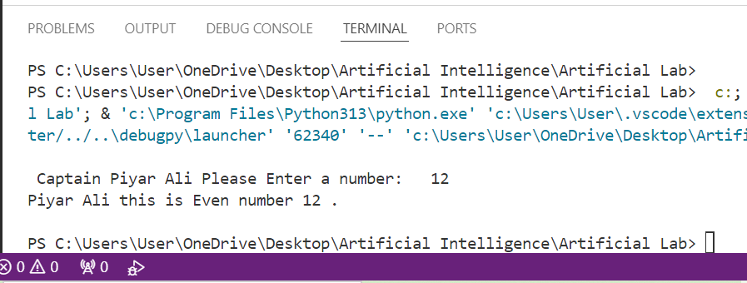

**Output: Odd**

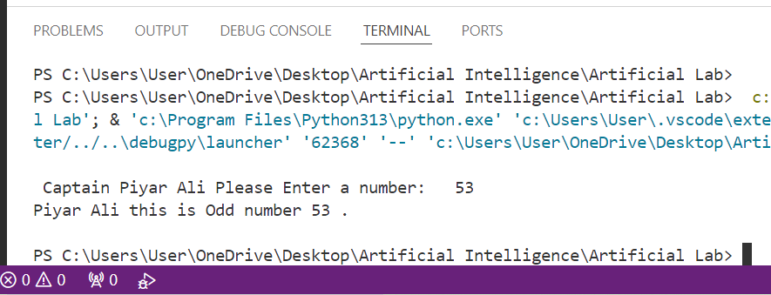

* **Write a Python function to find the maximum of three numbers.**

**Code:**

# Write a Python function to find the maximum of three numbers.

#function:

def find_max(a,b,c):

    #Conditions:

     if a >= b and a >= c:

         return a

     elif b >= a and b >= c:

         return b

     else :

         return c

     #taken user input:

x = int(input("\n Piyar Ali plz = Enter the Frist number:  "))

y = int(input(" Piyar Ali plz = Enter the Second number:  "))

z = int(input(" Piyar Ali plz = Enter the Third number:  "))

# call function:

print( " The Max three numbers of : ",find_max(x,y,z))

**Output:**

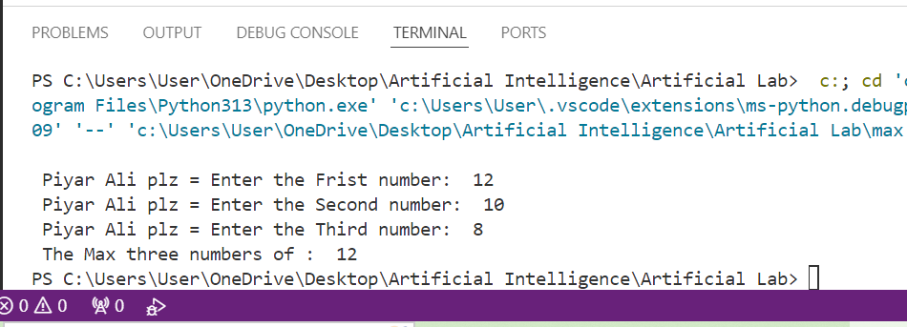

* **Make starred shapes using Loops:**

1. **Right-Angled Triangle:**

**Code:**

def right_angled_triangle(n):

    for i in range(1, n + 1):

        print('*' * i)

# Example usage

right_angled_triangle(6)

**output:**

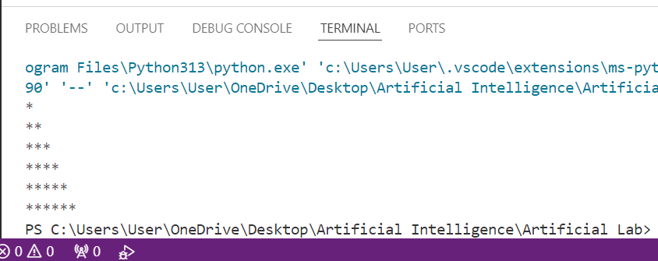

**2. Pyramid**

def pyramid(n):

    for i in range(1, n + 1):

        print(' ' * (n - i) + '*' * (2 * i - 1))

# Example usage

pyramid(5)

**output:**

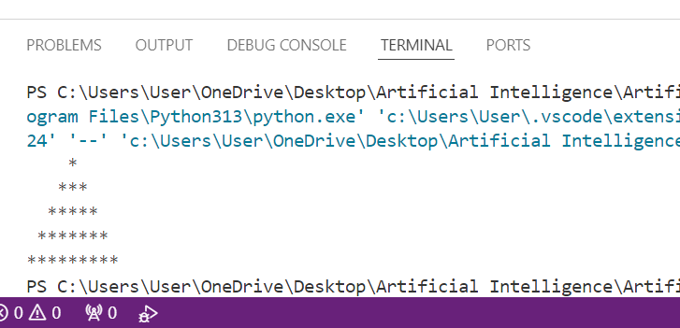

**3. Diamond Shape**

def diamond(n):

    # Upper part

    for i in range(1, n + 1):

        print(' ' * (n - i) + '*' * (2 * i - 1))

    # Lower part

    for i in range(n - 1, 0, -1):

        print(' ' * (n - i) + '*' * (2 * i - 1))

# Example usage

diamond(4)

**Output:**

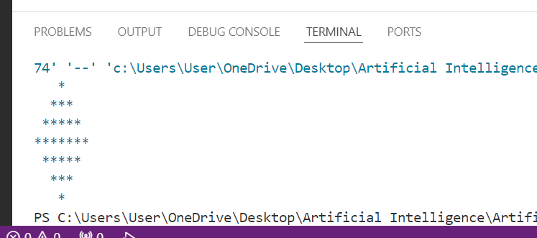

**4.Inverted Pyramid:**

**Code:**

def inverted_pyramid(n):

    for i in range(n, 0, -1):

        print(' ' * (n - i) + '*' * (2 * i - 1))

# Example usage

inverted_pyramid(5)

**output:**

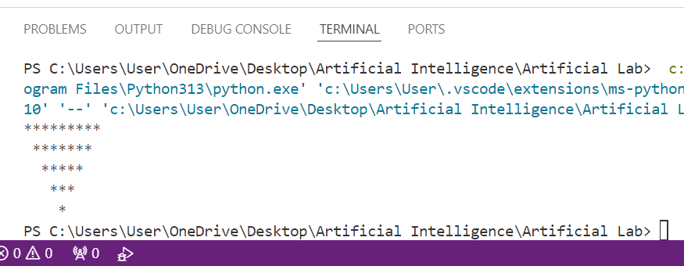

**5. Inverted Right-Angled Triangle:**

def inverted_right_angled_triangle(n):

    for i in range(n, 0, -1):

        print('*' * i)

# Example usage

inverted_right_angled_triangle(5)

**Output:**

